**LAB_Day-9 (String Methods)**

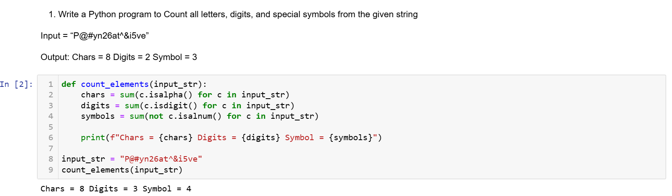

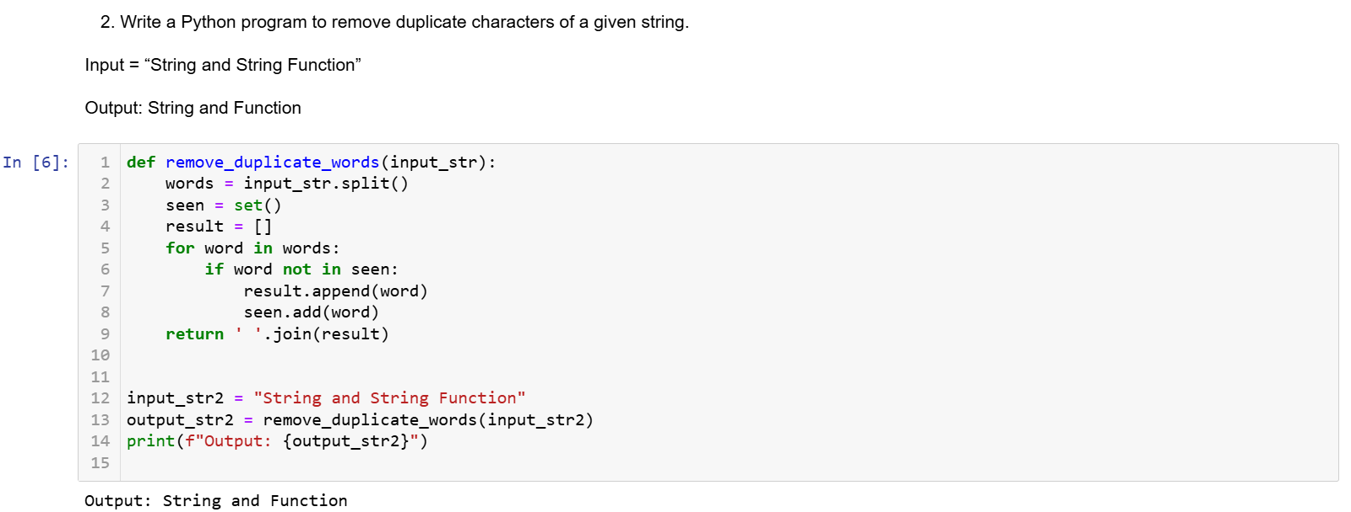

3. Write a Python program to count Uppercase, Lowercase, special character and numeric values in a given string

Input = “Hell0 W0rld ! 123 * # welcome to pYtHoN”

Output: UpperCase : 5

LowerCase : 18

NumberCase : 5

SpecialCase : 11

